Opening Dialog Menu

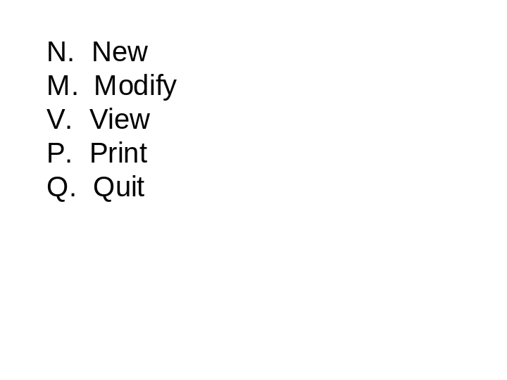

Student enters in one of the letters in a prompt.
New Graduation Plan Dialog

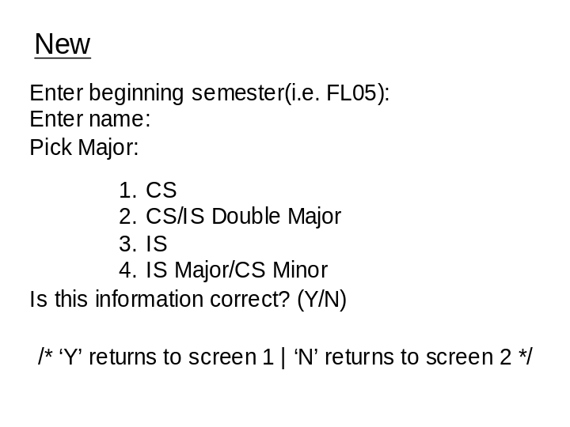

Student first enters the semester formatted FL/SP and year in short form.
Then student enters name.
The student is given a menu and is prompted to pick one.
The student is prompted over finalization of this process and is sent back to the main dialog regardless of ‘yes’ or ‘no.’
Modify Graduation Plan Dialog

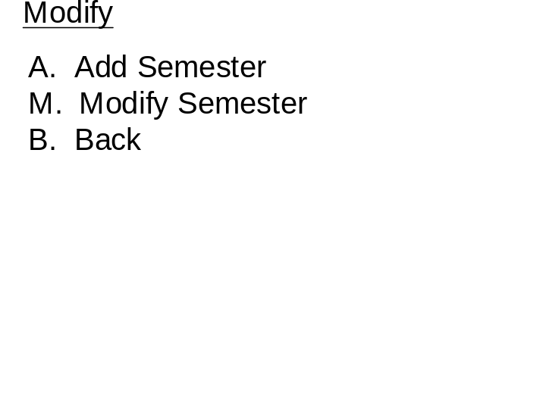

The student is prompted for a selection and taken to the appropriate screen.
Add Semester Dialog

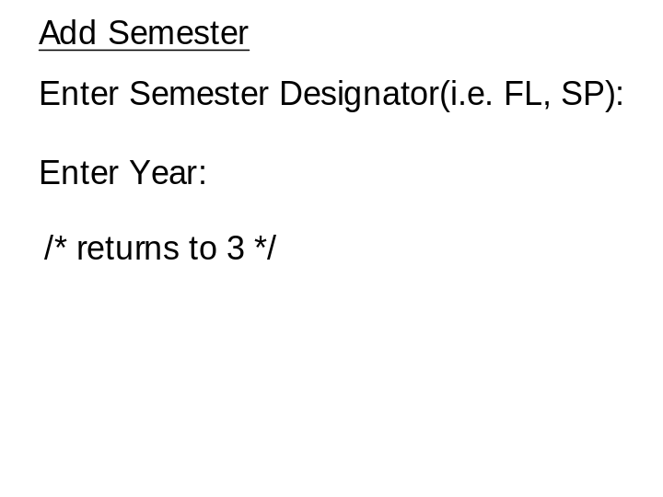

The student is prompted to enter a semester (formatted).
The student is then prompted for enter a year and this screen returns to the Modify screen.
Modify Semester Dialog

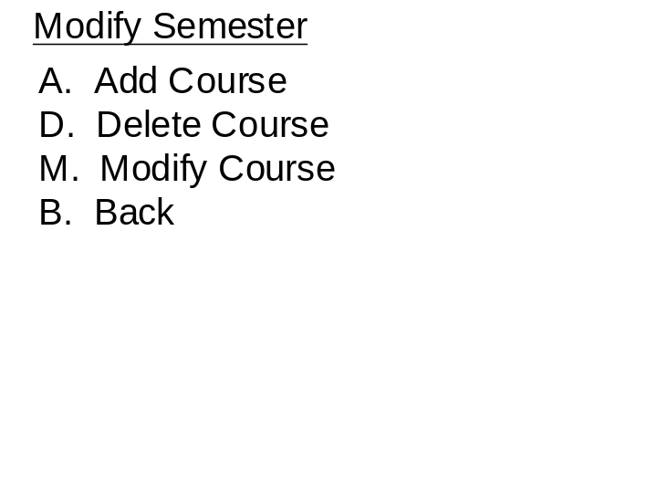

The student is prompted for a selction.
Add Course Dialog

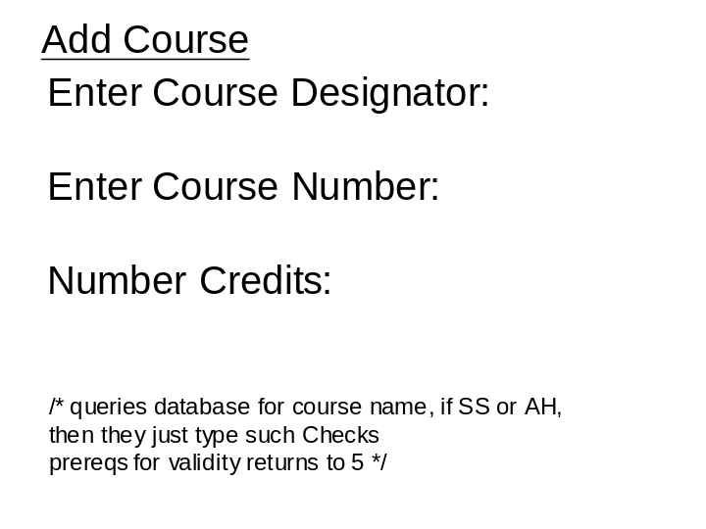

The student is prompted to enter the course designator (i.e. CMSC).
The student is prompted to enter the course number and then the number of credits. This screen will return certain information pending the validity of the input. Also this prompt will accept SS or AH as input instead of a real course designator.
Delete Course Dialog

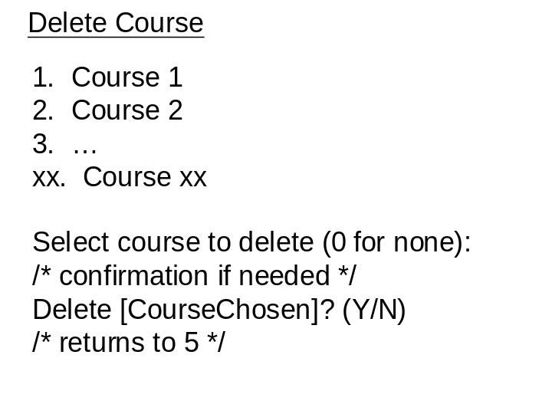

The program outputs a menu of courses in record. The student is prompted which to delete, and is prompted to confirm.
Modify Course Dialog

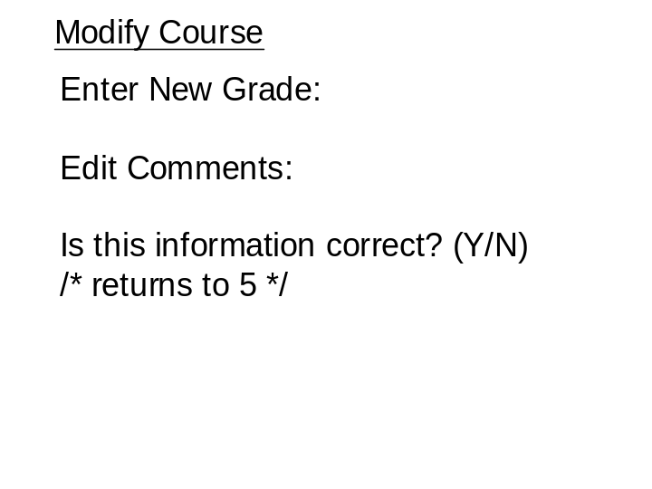

The student is prompted to enter a new grade and then for comments. The student is prompted to confirm changes.
Print Dialog

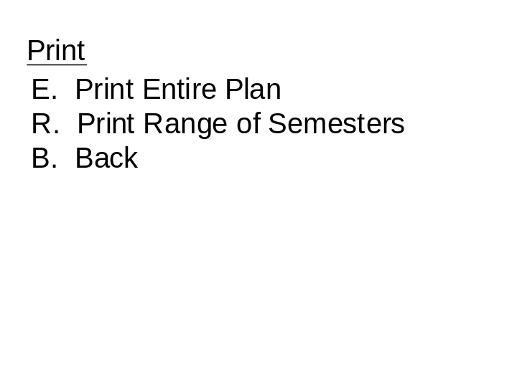

The student is prompted for a selection.
Print Range of Semesters Dialog

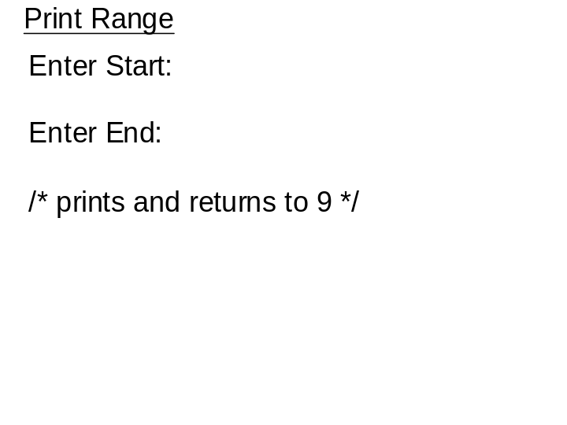

The student is prompted for a starting and ending semester to print this range.
Print Entire Plan Dialog

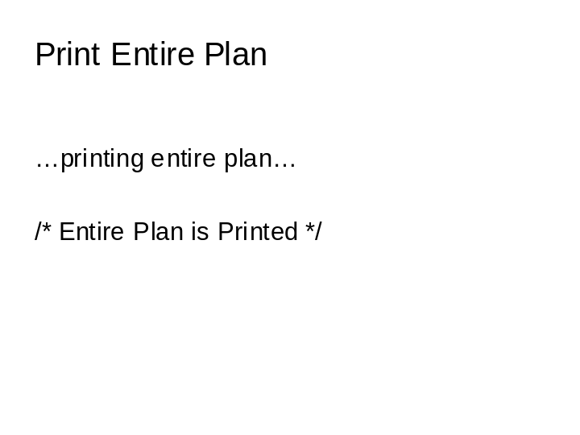

This just prints the entire plan, and there is no input for the user.
View Dialog

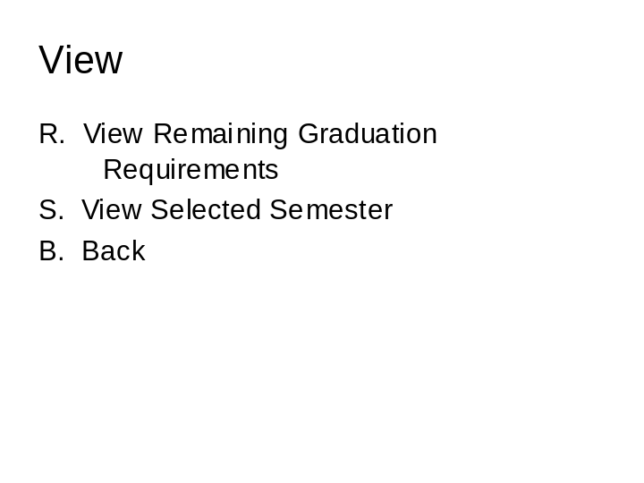

View Remaining Graduation Requirements Dialog

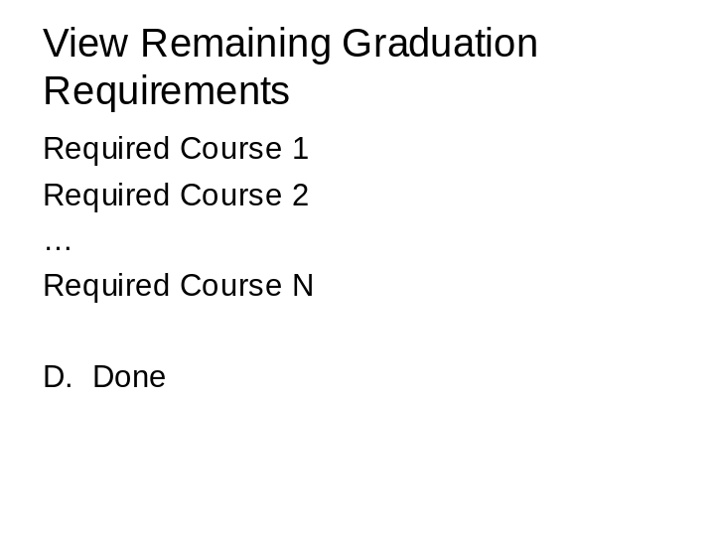

Select Semester Dialog

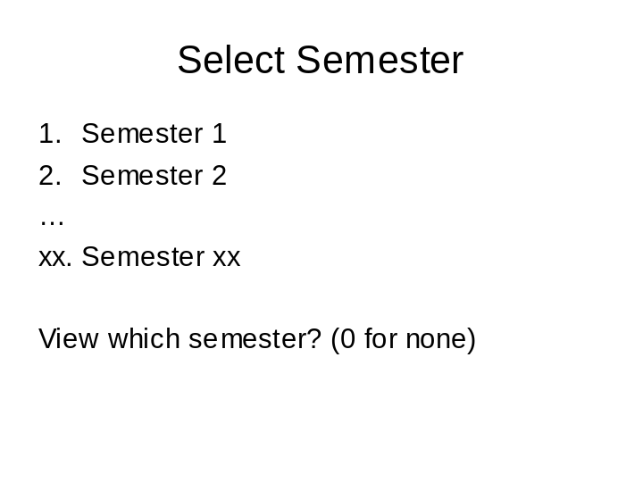

Select Course Dialog

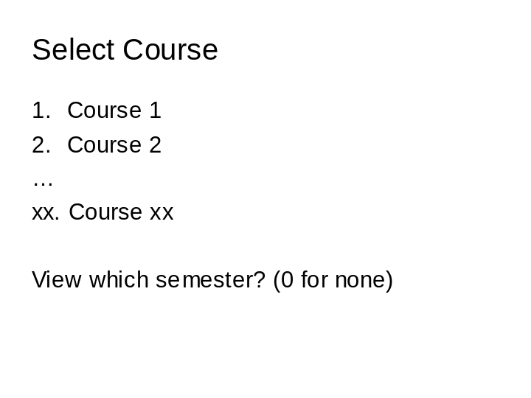

View Course Dialog

